Record Keepers Report

John Kamau

18/07/2019

# Q7 Do you have a specific designation or role in the group?

|  |  |  |
| --- | --- | --- |
| Role | Mali | Uganda |
| Yes (please specify) | 146 | 106 |
| No | 8 | 12 |
| Respondents | 154 | 118 |

# Q7 Do you have a specific designation or role in the group? (Answered Yes)

|  |  |  |
| --- | --- | --- |
| Q_7_S | Mali | Uganda |
| caissière | 51 | NA |
| comparable | 1 | NA |
| compte l’argent | 41 | NA |
| détentrice de la caisse | 5 | NA |
| garder l’argent | 2 | NA |
| noter les cotisations | 1 | NA |
| présidente | 1 | NA |
| Record Keeper | 27 | 106 |
| tenir des registres | 10 | NA |
| trésorière | 7 | NA |
| Respondents | 146 | 106 |

# Q8 And in that role, what are your duties? Thank you. And what else? (Multiple Selection)

|  |  |  |
| --- | --- | --- |
| Value | Mali | Uganda |
| Keep written financial records | 89 | 114 |
| Remember how much people owe | 104 | 83 |
| Decide the penalties that members pay | 58 | 18 |
| Resolve conflicts around repayment | 53 | 45 |
| Resolve other conflicts between members | 56 | 20 |
| Train someone else to help keep the records | 38 | 42 |
| Compute the share out | 62 | 58 |
| It is an honorary or ceremonial post with no duties | 20 | 2 |
| Other (please specify) | 26 | 7 |
| Keep the savings balance safe | 12 | 34 |
| bring savings to the account | 3 | 16 |
| conduct all responsibilities with the account | 3 | 11 |
| Respondents | 154 | 118 |

# Q9 Are there other members who could fulfill your post, if you were not around? (Multiple Selection)

|  |  |  |
| --- | --- | --- |
| Qualified | Mali | Uganda |
| Yes, many | 89 | 18 |
| Yes, a few | 51 | 80 |
| I am training my replacement now | 5 | 11 |
| No, I am necessary. | 11 | 1 |
| I don’t know | NA | 15 |
| Respondents | 154 | 118 |

# Q10 When was the group formed? I don’t know

## Years Mali Uganda  
## 1 less than 1 year <NA> 1  
## 2 1-5years <NA> 1  
## 3 6-10 years 82 51  
## 4 11-15 years <NA> 3  
## 5 Over 15 years <NA> 1  
## 6 Respondents 82 57

# Q12 FUNCTION: How does the group operate?

|  |  |  |
| --- | --- | --- |
| Operate | Mali | Uganda |
| The group retains savings from meeting to meeting with prime purpose to lend out and give savings back (DISTRIBUTING ASCA) | 141 | 101 |
| The group retains savings indefinitely and lends to members for investment, household expenses, or to pay for members’ emergencies such as funerals (NON DISTRIBUTING ASCA) | 13 | 1 |
| The group collects savings at every meeting, and gives all the collected funds to one member in turn, and the group retains no money from meeting to meeting (ROSCA) | NA | 2 |
| Other (specify) | NA | 14 |
| Respondents | 154 | 118 |

# Q13 PURPOSE: What is the primary reason the group came together?

|  |  |  |
| --- | --- | --- |
| Reason | Mali | Uganda |
| Non-specific financial services | 4 | 61 |
| Farmers group | NA | 12 |
| Social group | 89 | 20 |
| Women’s group | 28 | 3 |
| Business group | NA | 6 |
| Other (specify) | 33 | 16 |
| Respondents | 154 | 118 |

# 21 How often does your group meet?

|  |  |  |
| --- | --- | --- |
| meetings | Mali | Uganda |
| Weekly | 150 | 116 |
| Every 2 weeks | 4 | 1 |
| Monthly | NA | 1 |
| Respondents | 154 | 118 |

# Q23 How does the group save?

|  |  |  |
| --- | --- | --- |
| Savings | Mali | Uganda |
| Each member saves exactly the same at every meeting during the cycle (but some members can save for 2 or 3 “mains”) | 137 | 6 |
| Each member saves the same at each meeting, but the amount fluctuates according to the economic situation (hunger months, we save less) (but some members can save for 2 or 3) | 3 | 11 |
| Each member can decide each meeting what to save, but minimum of one share, and there is a maximum number of shares | 9 | 75 |
| Each member can decide each meeting, no minimum but a maximum number of shares | 3 | 2 |
| Each member can decide each meeting what to save, no minimum, no maximum | 2 | 6 |
| Other (specify) | NA | 2 |
| Respondents | 154 | 102 |

# Q25 How many members started this cycle?

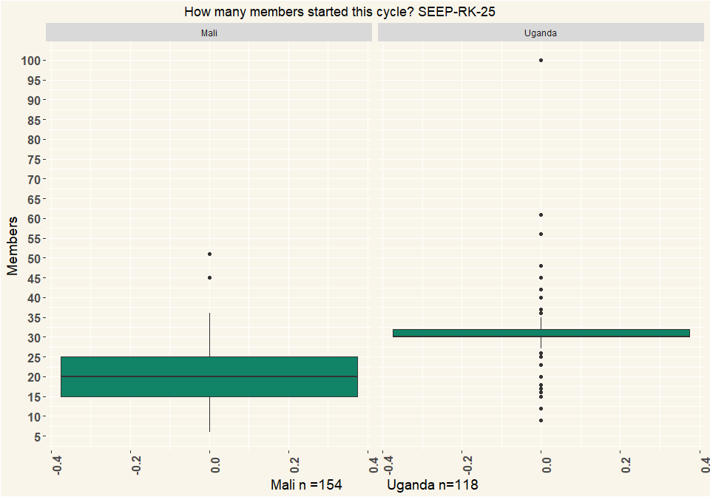

# Q26 At the beginning of current cycle, how many of those members were women?

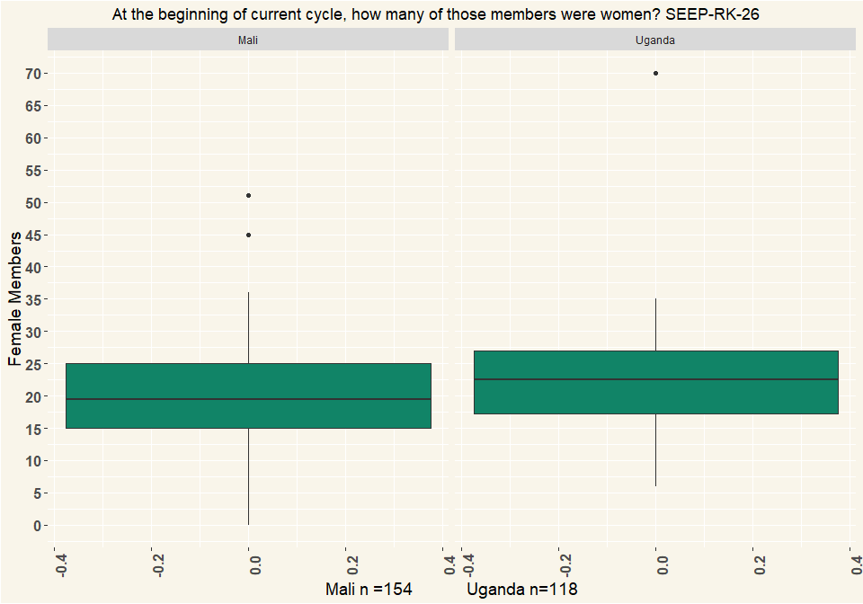

# Q27 Are members allowed to withdraw their savings during the cycle?

|  |  |  |
| --- | --- | --- |
| Withdraw | Mali | Uganda |
| Yes | 22 | 5 |
| No | 119 | 96 |
| Respondents | 141 | 101 |

# Q30 How many share outs do you remember and can you tell us about?

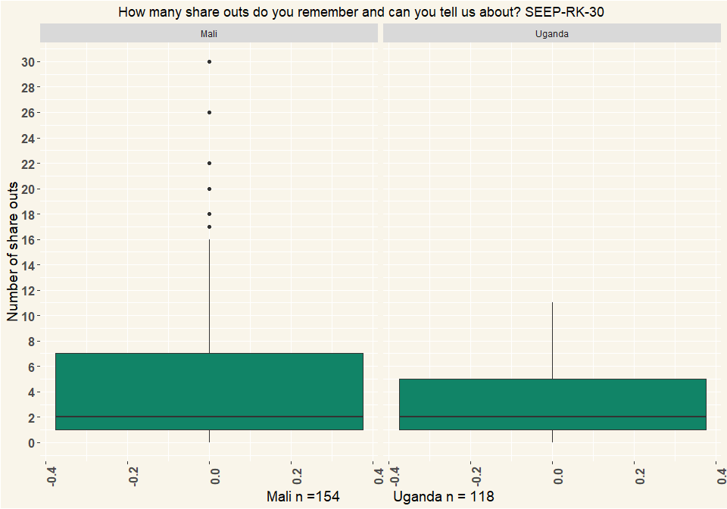

# Q33 How many members participated in the share out?

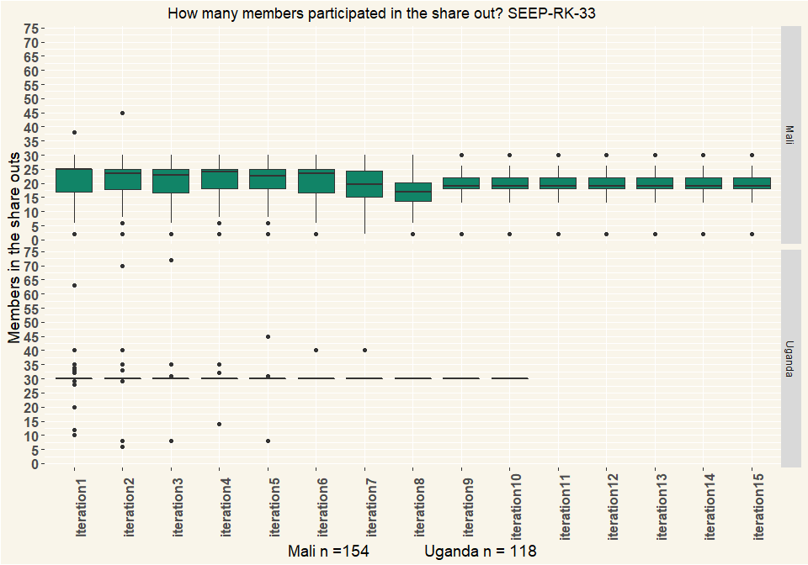

# Q34 Were there any members who could not repay all their loans at share out?” (Multiple Selection)

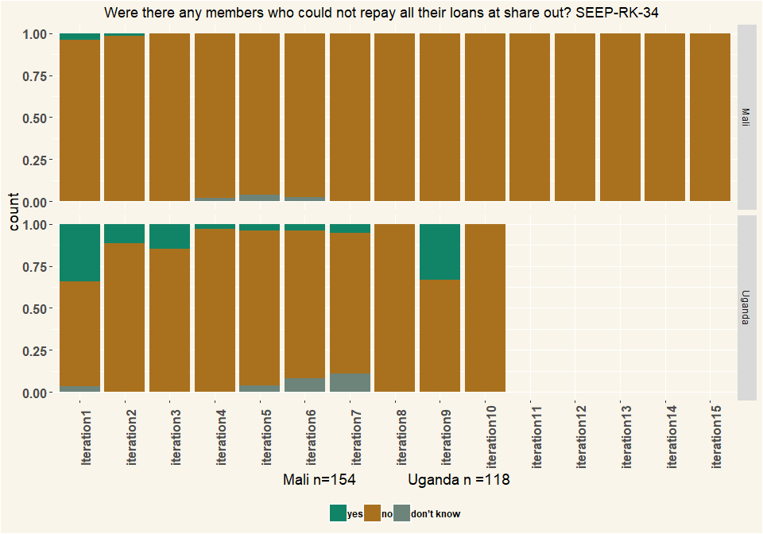

# Q38 How many members does your group have today?

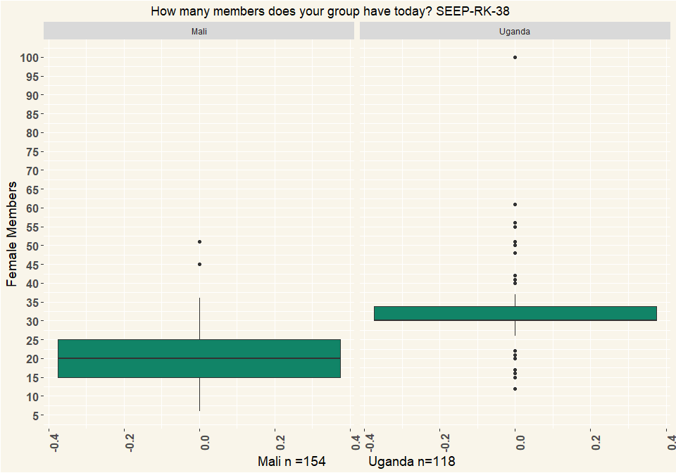

# Q39 Thinking back to the most recent meeting of your group

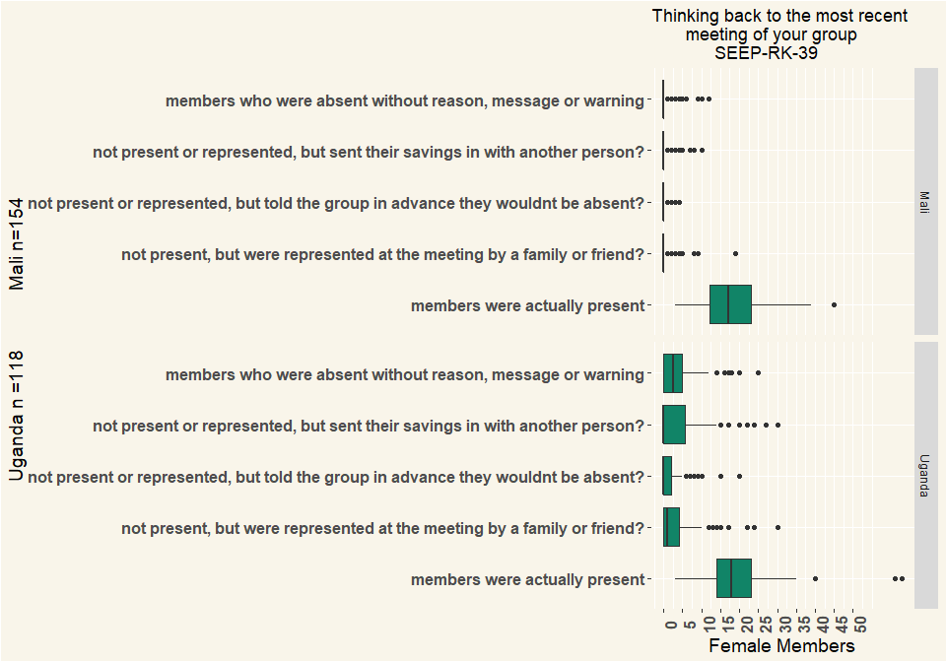

# Q40 How are records kept in your group? What I mean by that, How do you know, from one meeting to the next, how much each person has saved, and each person has borrowed? (Multiple Selection)

|  |  |  |
| --- | --- | --- |
| Records | Mali | Uganda |
| Central ledger | 106 | 86 |
| Passbooks | 42 | 86 |
| Memory based system | 33 | 1 |
| Don’t know, can’t say | 14 | 7 |
| Respondents | 154 | 118 |

# Q41 When the group conducts a transaction (for example, a member deposits savings or makes a loan repayment) how is the money handled? (multiple Selection)

|  |  |  |
| --- | --- | --- |
| Records | Mali | Uganda |
| Member brings it to the money counter(s), who counts the money and confirm the amount to the Recordkeeper | 109 | 109 |
| Member brings it to the money counter(s), who don’t count the money and put it in a box | 64 | 4 |
| Member brings it to the Recordkeeper, who counts the money and confirms the amount | 14 | 6 |
| Member brings it to the Recordkeeper, the money is not counted, the amount is not confirmed | 1 | NA |
| Group does not use cash (describe) | NA | 1 |
| Other | 2 | 2 |
| Respondents | 154 | 118 |

# Q42 How is money kept between meetings? (Multiple Selection)

|  |  |  |
| --- | --- | --- |
| Money | Mali | Uganda |
| In a cashbox or other secure container. One person keeps the box, two or more people have keys | 21 | 100 |
| In a cashbox or other secure container. One person keeps the box, one person has keys | 117 | 2 |
| In a cashbox or other secure container. Same person keeps box and key. | 2 | 2 |
| In a box or container, unlocked. | NA | 1 |
| Money is split up among members | NA | 25 |
| Bank account | NA | 7 |
| We never have cash because we lend out all the money | NA | 1 |
| Other | 14 | 2 |
| Respondents | 154 | 118 |

# Q44 Has your group ever had money stolen?

|  |  |  |
| --- | --- | --- |
| Money | Mali | Uganda |
| Yes | 2 | 8 |
| No | 139 | 91 |
| I don’t know | NA | 2 |
| Respondents | 141 | 101 |

# Q47 Does your group still receive visits from {NGO name}?

|  |  |  |
| --- | --- | --- |
| Visit | Mali | Uganda |
| Yes | NA | 21 |
| No | 154 | 97 |
| Respondents | 154 | 118 |

# Q48 How often does the group receive visits from {NGO name}?

|  |  |  |
| --- | --- | --- |
| Visit | Mali | Uganda |
| Every week | NA | 2 |
| Every two weeks | 1 | 1 |
| Every year | NA | 1 |
| Sporadically, once every few years | NA | 7 |
| It varies | NA | 9 |
| Other (specify) | NA | 1 |
| Respondents | 1 | 21 |

# Q50 Did someone help the group at last share-out?

|  |  |  |
| --- | --- | --- |
| Help | Mali | Uganda |
| Yes | 16 | 39 |
| No | 125 | 62 |
| Respondents | 141 | 101 |

# Q51 Who provided help?

|  |  |  |
| --- | --- | --- |
| Help | Mali | Uganda |
| former trainer | NA | 7 |
| l’enseignant | 2 | NA |
| Lamine Diarra secrétairecdu groupe | 1 | NA |
| NGO or CBO | 2 | 5 |
| Volunteer or Village Agent or Replicator | 12 | 27 |
| Respondents | 17 | 39 |

# Q52 Do you or anyone in your group know how to calculate the share out so that each person gets the right amount?

|  |  |  |
| --- | --- | --- |
| calculate | Mali | Uganda |
| Yes | 104 | 71 |
| No | 37 | 19 |
| I don’t know myself and I don’t know whether others can do it | NA | 11 |
| Respondents | 141 | 101 |

# Q53 How many members know how to calculate the share-out?

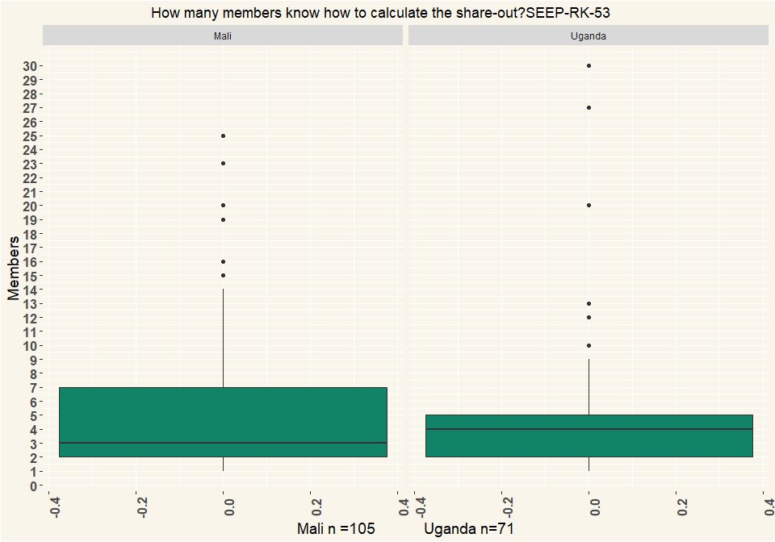

# Q54 Why don’t more members know how to calculate the share-out?

|  |  |  |
| --- | --- | --- |
| Calc | Mali | Uganda |
| They don’t need to, we have enough, we are happy the way it is | 40 | 9 |
| They are not educated or literate | 91 | 47 |
| No one has shown us | 19 | 11 |
| Other: | 4 | 7 |
| Respondents | 154 | 118 |

# Q55 The most recent time you shared out, did all the members receive the amount they expected?

|  |  |  |
| --- | --- | --- |
| calculate | Mali | Uganda |
| Yes, all were content | 133 | 82 |
| Yes, more or less, most were content | 3 | 13 |
| No, a few challenged the amount they got | 3 | 4 |
| No, some were very dissatisfied | 2 | 1 |
| Other (specify) | NA | 1 |
| Respondents | 141 | 101 |

# Q56 What caused the amount to be lower than expected?”

|  |  |  |
| --- | --- | --- |
| Calc | Mali | Uganda |
| We lost money from late loans | NA | 4 |
| We lost money but we don’t know how | 2 | NA |
| Some members were suspicious about calculations | NA | 1 |
| Some members are never happy | NA | 1 |
| Don’t know | 2 | 1 |
| other (specify) | 2 | NA |
| Respondents | 154 | 118 |

# Q57 How long is a savings cycle usually in months?

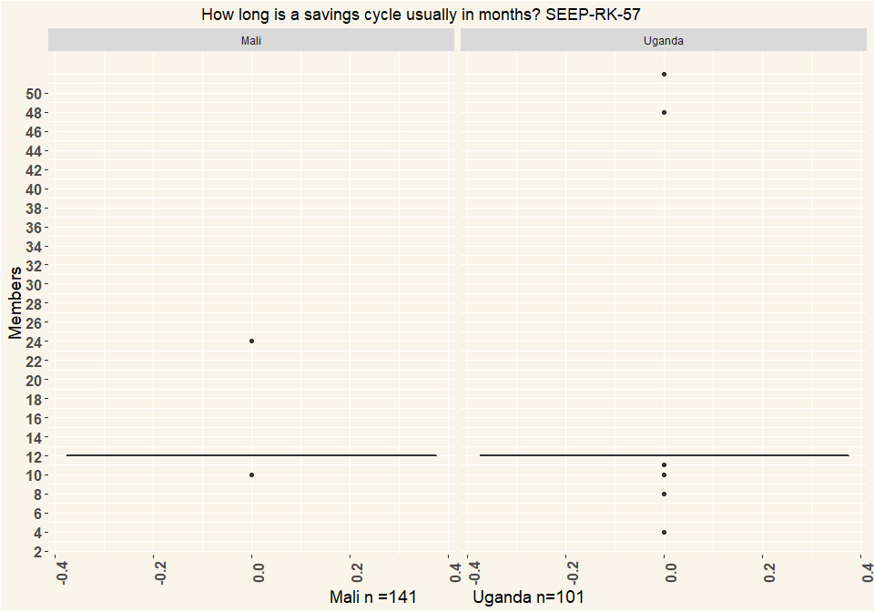

# Q58 How is the share-out calculated?

|  |  |  |
| --- | --- | --- |
| calculate | Mali | Uganda |
| Everybody gets back what they saved and paid (interest paid on loans goes back to the person paying) | 46 | 18 |
| Everybody gets their saving back and the remainder split equally amongst the members | 41 | 2 |
| Everybody gets their savings back and the interest is distributed proportionately | 41 | 75 |
| All the money is split up evenly among all the members regardless of how they have saved. | NA | 2 |
| Everybody gets an exact share according to participation (1, 2 or 3 ‘mains’) | 13 | 2 |
| other (specify) | NA | 2 |
| Respondents | 141 | 101 |

# Q59 Does your group charge fines for members who break the rules?

|  |  |  |
| --- | --- | --- |
| Fines | Mali | Uganda |
| Yes | 145 | 112 |
| No | 9 | 4 |
| In principle yes but in reality no | NA | 2 |
| Respondents | 154 | 118 |

# Q60 What are some of the things that members are fined for? (Multiple Selection)

|  |  |  |
| --- | --- | --- |
| Fines | Mali | Uganda |
| Talking during meeting | 125 | 67 |
| Late to meeting | 151 | 103 |
| Late repayment | 125 | 79 |
| Not saving | 129 | 43 |
| Arguments, saying bad things | 81 | 45 |
| Phone ringing during meeting | 14 | 12 |
| Other: | 2 | 14 |
| Respondents | 154 | 118 |

# Q61 Is the group registered with any government authority? E.g. with the municipality, ministry of cooperatives, chamber of commerce, etc.

|  |  |  |
| --- | --- | --- |
| Registration | Mali | Uganda |
| Yes | 38 | 64 |
| No | 106 | 48 |
| I don’t know | 10 | 6 |
| Respondents | 154 | 118 |

# Q62 Does the group have a relationship with a financial service provider?

|  |  |  |
| --- | --- | --- |
| Financial | Mali | Uganda |
| Yes, as a group | 6 | 25 |
| Yes, but individual members | 6 | 28 |
| No, nobody has any relationship | 139 | 53 |
| I don’t know | 3 | 12 |
| Respondents | 154 | 118 |

# Q63 What type of relationship(s) does the group have with a financial service provider?

|  |  |  |
| --- | --- | --- |
| Relation | Mali | Uganda |
| Individual group members have accounts (unrelated to the group) | 6 | 40 |
| Individual group members have loans (unrelated to the group, group not guaranteeing loan) | 5 | 25 |
| Individual group members have accounts as a result of the group | NA | 1 |
| group guaranteeing loan or member’s track record helping to get the loan | 6 | 20 |
| Group has a loan from financial service provider | 1 | 3 |
| Respondents | 18 | 89 |

# Q64 In what type of institution does the group have an account?

|  |  |  |
| --- | --- | --- |
| Relation | Mali | Uganda |
| Commercial Bank | NA | 5 |
| MFIs | 4 | 2 |
| MNO (mobile money) | NA | 4 |
| I don’t want to answer | 1 | NA |
| Respondents | 5 | 11 |

# Q67 Does the group use mobile money for group activities?

|  |  |  |
| --- | --- | --- |
| Mobile | Mali | Uganda |
| Yes | NA | 1 |
| No | 150 | 115 |
| I don’t know | 4 | 2 |
| Respondents | 154 | 118 |

# Q69 Does the group use any form of technology for recordkeeping? E.g. calculator on phone? an app on a phone to do bookkeeping?

|  |  |  |
| --- | --- | --- |
| Tech | Mali | Uganda |
| Yes | 33 | 112 |
| No | 121 | 6 |
| Respondents | 154 | 118 |

# Q70 What forms of technology does the group use? (Multiple Selection)

|  |  |  |
| --- | --- | --- |
| Tech | Mali | Uganda |
| Stand-alone calculator | 31 | 58 |
| Calculator on simple phone | 26 | 98 |
| Calculator on smart phone | 20 | 9 |
| Sending messages on simple phone | 2 | 9 |
| Sending messages on smart phone | NA | 4 |
| Recording numbers or balances on smart phone | NA | 1 |
| Camera on simply phone | NA | 11 |
| Camera on smart phone | NA | 4 |
| Respondents | 34 | 112 |

# Q74 What is the gender of the respondent?

|  |  |  |
| --- | --- | --- |
| Gender | Mali | Uganda |
| Female | 152 | 71 |
| Male | 2 | 47 |
| Respondents | 154 | 118 |

# Q75 Could you estimate the age of the respondent? I don’t know

